The Association Between Sleep Efficiency and Selective Attention: The Moderating Role of Biological Sex

Aneeta Sadra

University of Essex Online

Module name: Psychology and Neuroscience July 2026

Date: 14th September 2026

Word count (excluding Timeline, References and Appendices): 1,907 words

Introduction

Background literature review
Sleep is important for cognitive functioning, particularly for higher-level cognitive processes such as executive function. Executive functions are a collection of cognitive processes that regulate and control other lower-level processes and are associated with frontal-lobe functioning (Chandler, 2015). Attention is an important part of cognitive functioning, as it allows individuals to focus on relevant information while ignoring information that is not relevant to the task. Selective attention is particularly important when individuals are required to respond to relevant information while dealing with distracting or conflicting information. This is relevant to the current study because the ability to control interference from irrelevant information can be affected by sleep.
Previous research has found a relationship between sleep and executive function. Sen and Tai (2023) reviewed evidence examining sleep duration and executive function in adults and found that poor sleep efficiency and sleep fragmentation were associated with poorer executive function. Their review also found that sleep deprivation can affect several aspects of cognitive performance, including sustained attention and reaction time. However, the authors suggest that sleep quality may be more important for executive functioning than sleep duration alone.
The relationship between sleep and cognitive control may be particularly relevant to selective attention. Wilckens et al. (2014) investigated the relationship between sleep continuity and executive function across younger and older adults. The researchers found that higher sleep continuity was associated with better cognitive performance. In younger adults, greater sleep continuity was associated with better working memory and inhibitory control. These findings suggest that the continuity of sleep may be related to cognitive processes involved in controlling responses and ignoring irrelevant information.
One possible explanation is that more continuous sleep allows individuals to progress normally through different sleep stages. Wilckens et al. (2014) suggested that lower sleep continuity may reduce the amount of time spent in slow-wave sleep, which has been associated with frontal-lobe functioning and cognitive performance. Research has also suggested that sleep deprivation can affect brain connectivity and activation in regions involved in goal-directed behaviour (Sen & Tai, 2023). Therefore, poorer sleep efficiency may potentially be associated with less effective functioning of neural systems involved in inhibitory control. This provides a possible mechanism through which sleep efficiency could be associated with selective attention.
Biological sex may also be relevant to the relationship between sleep and cognitive functioning. Hajali et al. (2019) reviewed evidence concerning sex differences in sleep and cognitive deficits following sleep loss. The review identified differences between males and females in sleep, responses to sleep loss and cognitive functioning. It also discussed the possible influence of gonadal hormones on sleep regulation and cognitive performance.
There is evidence that biological sex may be associated with differences in sleep characteristics. Hajali et al. (2019) report that studies using polysomnography have found that women may have longer total sleep time, shorter time taken to fall asleep and better sleep efficiency than men. These differences may be partly related to hormonal factors, as gonadal hormones have been suggested to influence sleep-wake cycles and sleep architecture.
There is also evidence that sleep loss may not affect cognitive functioning equally across biological sexes. For example, some studies reviewed by Hajali et al. (2019) found greater effects of sleep loss on alertness or certain cognitive measures in women, although the findings are not consistent across all cognitive domains. This inconsistency provides a reason to investigate whether biological sex moderates the relationship between naturally occurring differences in sleep and cognitive performance.
Overall, existing research provides evidence that sleep quality and continuity are related to executive functioning and inhibitory control, while biological sex may be associated with differences in sleep and responses to sleep loss. However, less is known about whether naturally occurring variation in sleep efficiency is associated specifically with selective attention and interference control, and whether this relationship differs according to biological sex.

Rationale and hypotheses
The current study will investigate the association between sleep efficiency and selective attention, with biological sex examined as a potential moderator. The study will focus on naturally occurring variation in sleep rather than experimentally restricting participants’ sleep. This is important because an observational design can investigate whether differences in normal sleep efficiency are related to differences in selective attention in everyday conditions.
Is sleep efficiency associated with selective attention, and does this relationship differ according to biological sex?
It is hypothesised that higher sleep efficiency will be associated with lower interference on the Flanker task, reflected by a smaller difference in reaction time between incongruent and congruent trials, and that this association will differ between groups defined by biological sex.

Aim and objectives
The aim of the study is to investigate the relationship between sleep efficiency and selective attention and examine whether biological sex moderates this relationship.
The objectives are to:
- Measure sleep efficiency objectively across several nights.
- Assess selective attention using a computerised Flanker task, with interference quantified from reaction time differences between congruent and incongruent trials.
- Examine the association between sleep efficiency and Flanker interference.
- Test whether biological sex moderates the relationship between sleep efficiency and selective attention.

Research Design

Design
A quantitative, observational and correlational design will be used. Sleep efficiency will be measured objectively over several nights before participants complete the Flanker task. The study will not manipulate participants’ sleep, meaning that causal conclusions cannot be made. Instead, the study will examine whether naturally occurring differences in sleep efficiency are associated with differences in selective attention.
Biological sex will be included as a moderator. This will allow the study to examine whether the strength of the relationship between sleep efficiency and selective attention differs between biological-sex groups.
The Flanker task is appropriate for assessing selective attention because participants must respond to a central target while ignoring surrounding stimuli (Eriksen & Eriksen, 1974). Comparing performance between congruent and incongruent trials provides an indication of interference. Therefore, participants with lower sleep efficiency may show greater interference on incongruent Flanker trials.

Materials
Sleep efficiency will be measured using a standardised actigraphy device, a non-invasive wrist worn device. Participants will wear the same device during the sleep-monitoring period. This will reduce differences caused by devices using different algorithms to estimate sleep.
Actigraphy provides an objective method of estimating sleep from movement and can provide measures of total sleep time, time taken to fall asleep and wake after sleep onset. Previous research has found that at least five nights of actigraphy measurement are recommended for obtaining a reliable measure of sleep efficiency (Aili et al., 2017). Therefore, participants will wear the device for seven consecutive nights, allowing sleep efficiency to be averaged across the monitoring period. Sleep efficiency will be calculated as the percentage of the relevant sleep period spent asleep.
Selective attention will be measured using a computerised Flanker task. Participants will be presented with five arrows and asked to identify the direction of the central arrow while ignoring the surrounding arrows. In congruent trials, the surrounding arrows will point in the same direction as the central arrow. In incongruent trials, the surrounding arrows will point in the opposite direction, creating interference. Reaction time and accuracy will be recorded, and the difference in reaction time between incongruent and congruent trials will be used as an indicator of interference.

Participants
Participants will be adults aged 18 years and above and provide basic demographic information, including biological sex. Participants will need to have access to the required technology and wear the wrist device for the full monitoring period.
A priori power analysis was conducted using WebPower for the planned moderation analysis. Assuming a medium effect size, alpha level of 0.05 and statistical power of 0.80, the analysis indicated a minimum sample size of 55 participants (Appendix A). There is limited evidence quantifying the specific sex and sleep-efficiency interaction, a medium effect was used as an initial planning assumption.
Recruitment will aim to obtain sufficient participants in each biological-sex group to allow the interaction between sleep efficiency and biological sex to be examined reliably.

Data analysis plan
First, the average sleep efficiency across the monitoring period will be calculated for each participant. An interference score will be calculated by subtracting the mean reaction time for congruent from the mean reaction time for incongruent trials. Accuracy will also be recorded as a secondary measure of task performance.
The association between sleep efficiency and Flanker interference will first be examined using correlation. A multiple regression will then test whether biological sex moderates this association. Sleep efficiency and biological sex will be included as predictors, together with their interaction. A significant interaction would indicate that the association between sleep efficiency and Flanker interference differs according to biological sex.

Procedure
Participants will receive a research information sheet and consent form, explaining the purpose of the study, what participation involves and how their data will be used (Appendix B).
Participants will complete demographic information and be provided with the wrist worn device. They will be instructed to wear the device during sleep for seven consecutive nights. After, participants will complete the computerised Flanker task. The instructions will explain that they should respond to the direction of the central arrow while ignoring the surrounding arrows. The task will contain both congruent and incongruent trials. Reaction time and accuracy will be recorded.
Testing conditions will be standardised as far as practicable, including the time of day at which the Flanker task is completed. This is relevant because time of day has been identified as a factor that can influence cognitive responses to sleep restriction (Lowe et al., 2017).
Ethics
The study is expected to involve minimal risk, but ethical considerations are still required because participants will provide information about their sleep. The British Psychological Society (BPS, 2021) emphasises respect for autonomy, privacy and dignity, informed consent, confidentiality and minimising potential harm in psychological research.
Participants will be informed that participation is voluntary and that they can withdraw according to the withdrawal procedure stated in the information sheet.
Sleep data will be treated as private information and will be stored securely. Participants will not be identifiable in the final report. The study will make clear that the data being collected are for research purposes and are not intended to diagnose sleep disorders or provide medical advice.
Ethical approval will be obtained by the University of Essex Online.

Limitations
Several limitations should be considered. First, the observational design means that the study can identify associations but cannot establish that sleep efficiency causes changes in selective attention. Wilckens et al. (2014) notes that other factors, such as stress, mood, depression, physical activity or general health, could influence both sleep and cognitive performance.
Second, actigraphy is a practical method for measuring sleep in a natural environment but does not provide the same information as laboratory polysomnography or EEG. Therefore, it provides an estimate of sleep rather than a direct measurement of sleep stages.
Third, biological sex is being used as a moderator, but the study will not directly measure hormones, menstrual-cycle phase, circadian rhythms or other biological mechanisms. Therefore, if a difference between groups is identified, the study will not be able to establish which biological mechanism explains the difference. This is particularly important because existing research suggests that sex hormones may contribute to differences in sleep but also indicates that the evidence is complex.
Finally, the Flanker task measures a specific aspect of cognition: selective attention and interference control. Therefore, findings should not be generalised to all forms of attention or overall cognitive functioning.

Timeline

Stage | Proposed timeframe
- Finalise literature review and research design  - Ethics preparation and approval  - Participant recruitment  - Seven-night monitoring  - Flanker testing  - Data analysis  - Final report | Week 1  Week 2  Weeks 3-4  Weeks 4-5  Weeks 5-6  Week 6  Weeks 7-8

Appendix A
A priori power analysis
WebPower output for the planned moderation analysis examining whether biological sex moderates the association between sleep efficiency and selective attention.

Appendix B
Research Information Sheet and Consent Form

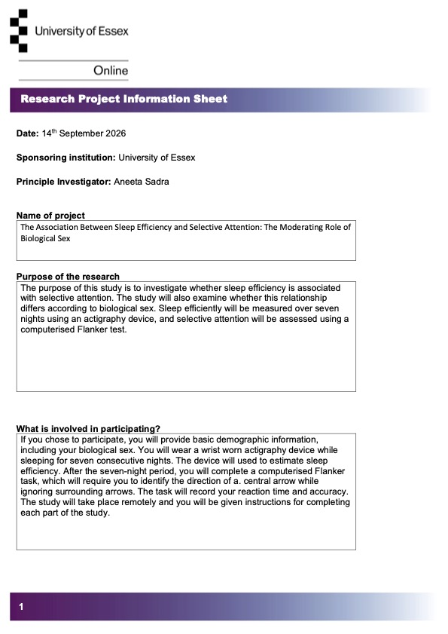
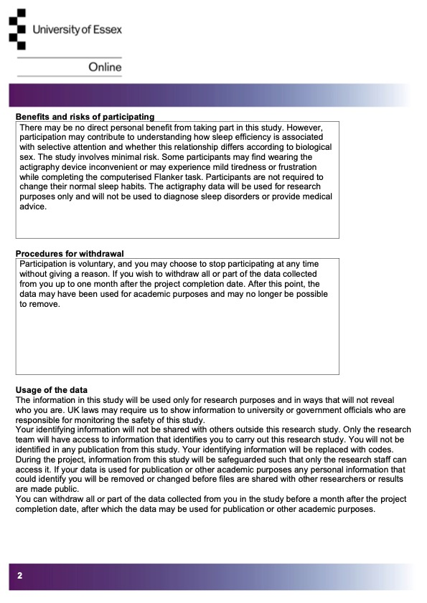

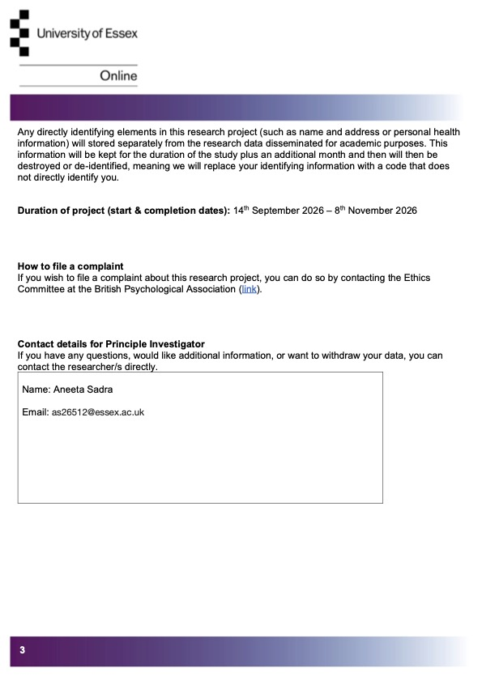

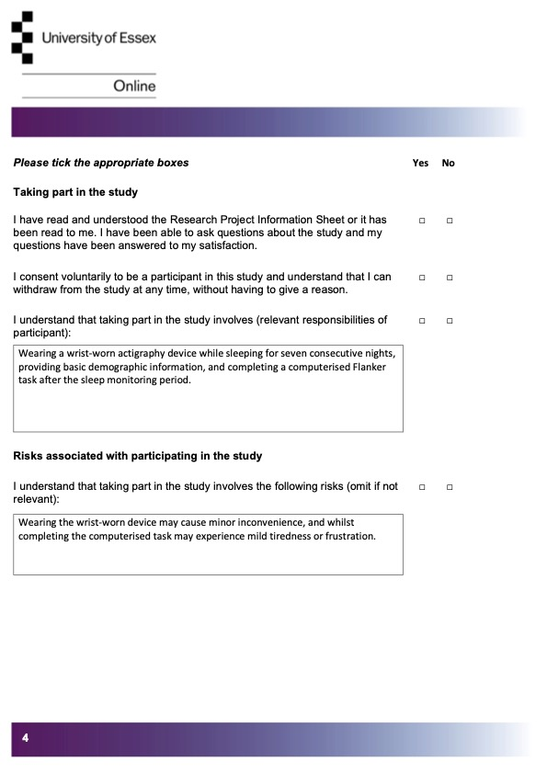

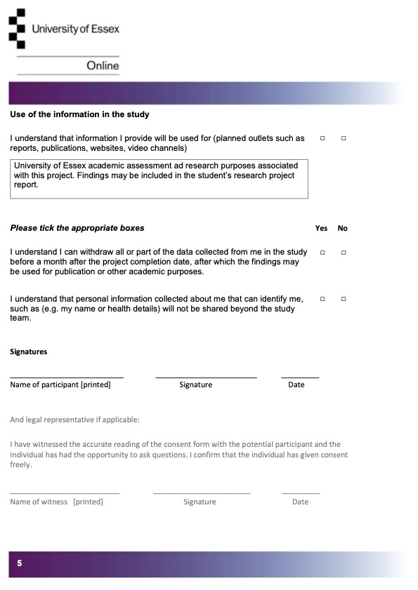

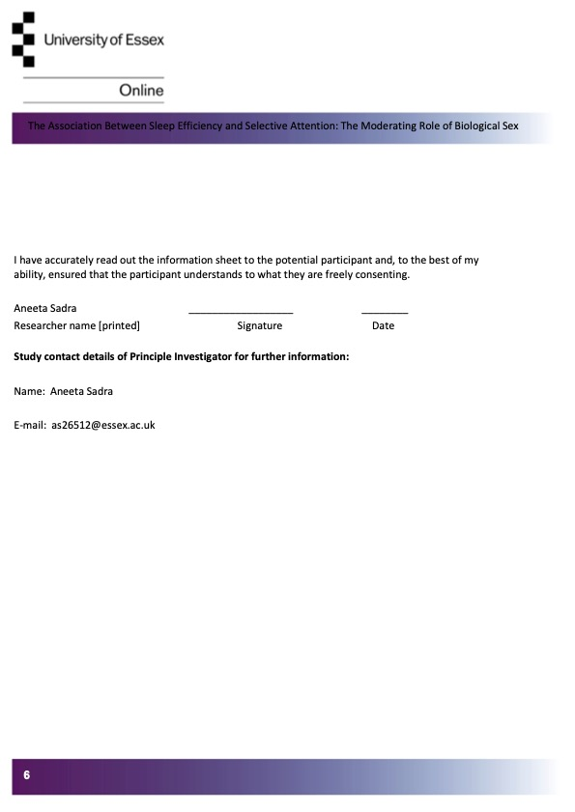

References
Aili, K., Åström-Paulsson, S., Stoetzer, U., Svartengren, M., & Hillert, L. (2017). Reliability of actigraphy and subjective sleep measurements in adults: The design of sleep assessments. Journal of Clinical Sleep Medicine, 13(1), 39–47. https://doi.org/10.5664/jcsm.6384
British Psychological Society. (2021). Code of human research ethics. https://doi.org/10.53841/bpsrep.2021.inf180
Chandler, C. (2015). Psychobiology. Wiley.
Eriksen, B. A., & Eriksen, C. W. (1974). Effects of noise letters upon the identification of a target letter in a nonsearch task. Perception & Psychophysics, 16(1), 143–149. https://doi.org/10.3758/BF03203267
Hajali, V., Andersen, M. L., Negah, S. S., & Sheibani, V. (2019). Sex differences in sleep and sleep loss-induced cognitive deficits: The influence of gonadal hormones. Hormones and Behavior, 108, 50–61. https://doi.org/10.1016/j.yhbeh.2018.12.013
Lowe, C. J., Safati, A., & Hall, P. A. (2017). The neurocognitive consequences of sleep restriction: A meta-analytic review. Neuroscience & Biobehavioral Reviews, 80, 586–604. https://doi.org/10.1016/j.neubiorev.2017.07.010
Sen, A., & Tai, X. Y. (2023). Sleep duration and executive function in adults. Current Neurology and Neuroscience Reports, 23(11), 801–813. https://doi.org/10.1007/s11910-023-01309-8
Wilckens, K. A., Woo, S. G., Kirk, A. R., Erickson, K. I., & Wheeler, M. E. (2014). Role of sleep continuity and total sleep time in executive function across the adult lifespan. Psychology and Aging, 29(3), 658–665. https://doi.org/10.1037/a0037234
AI Acknowledgment: ChatGPT was used to support my understanding of research concepts and statistical methods, to brainstorm ideas and provide feedback on the structure of this report.

